2.Develop a system using UML for implementing the Book Bank process. It should verify the details of the student by the central computer. The details regarding the student will be provided to the central computer through the administrator in the book bank and the computer will verify the details of the student and provide approval to the office. Then the books that are needed by the student will issue from the office to him

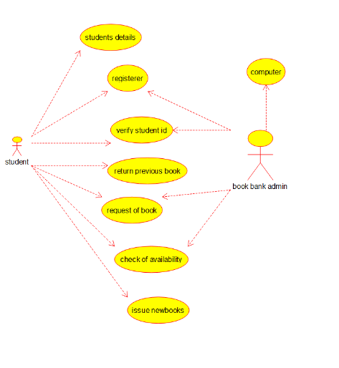

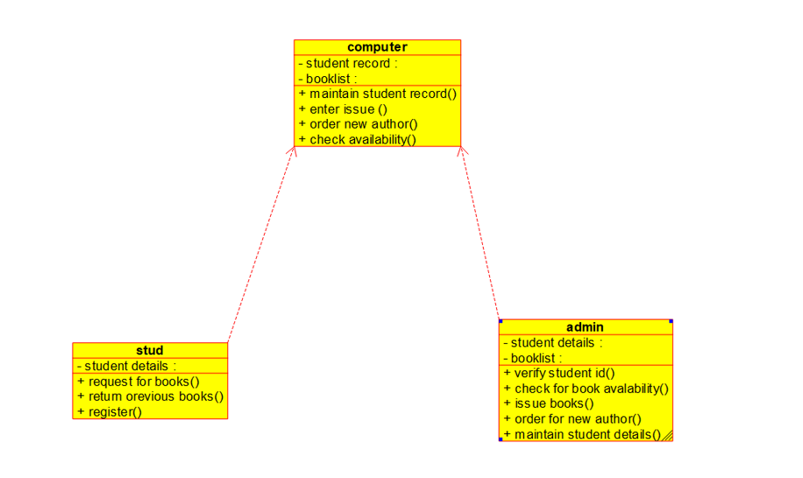

3.Develop a system using UML for implementing the Exam Registration Portal. It should verify the details of the candidate by the central computer. The details regarding the candidate will be provided to the central computer through the administrator and the computer will verify the details of the candidate and provide approval. Then the hall ticket will be issued from the office to the candidate.

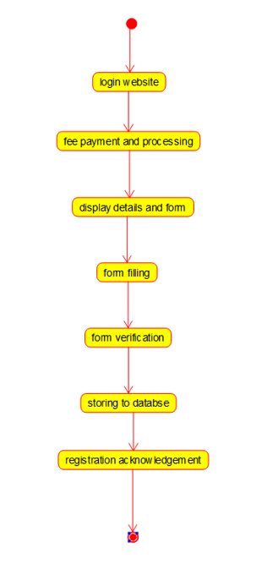

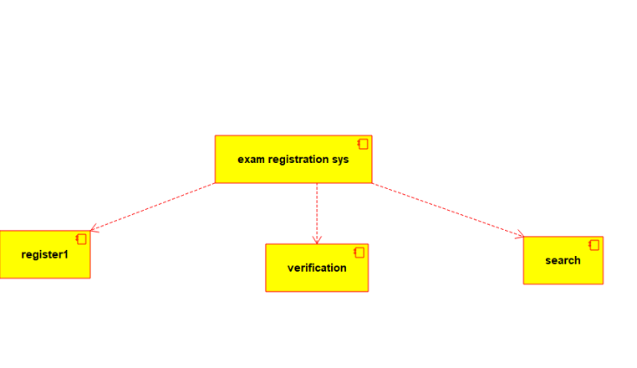

4. Develop a system using UML for implementing Stock Maintenance System. In this system, the customer can place orders and purchase items with the aid of the stock dealer and central stock system. These orders are verified and the items are delivered to the customer. Then the stock details are to be updated accordingly

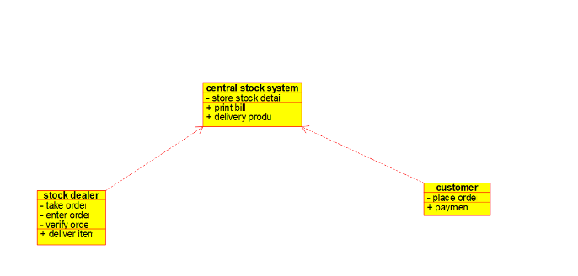

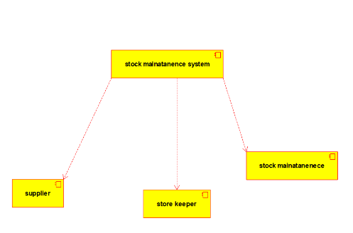

5. Develop a system using UML for implementing Online Course Reservation System. This system is organized by the central management system. The student first browses and selects the desired course of their choice. The university then checks the availability of the seat if it is available the student is enrolled for the course

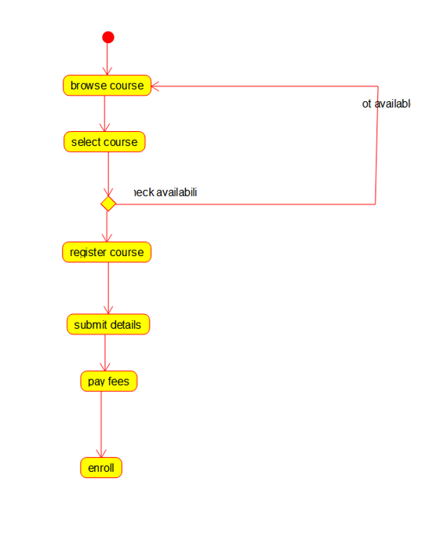

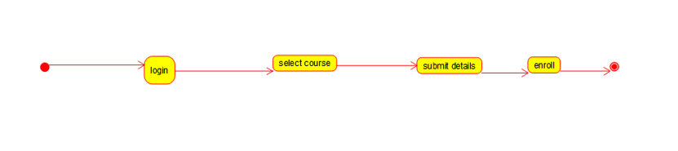

6. Develop a system using UML for implementing E-Ticketing System. This is to be used by the passenger for reserving the tickets for their travel. This E-ticketing is organized by the central system. The information is provided by the railway reservation system.

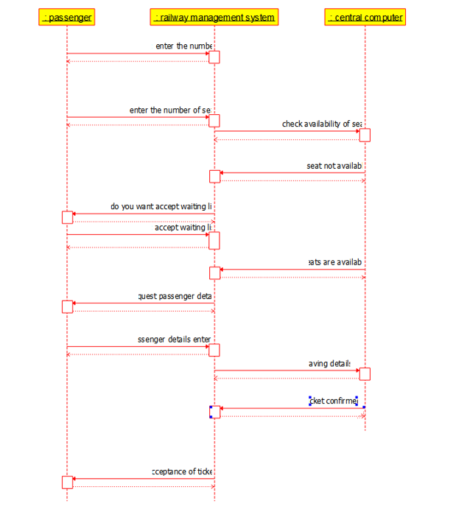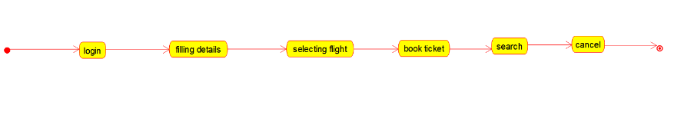

7.Develop a system using UML for implementing Credit Card Processing System. In this system, the cardholder can purchase items and pays the bill with the aid of a credit card. The cashier should accept the card and proceed with the transaction using the central system. The bill is to be verified and the items are delivered to the cardholder based on it.

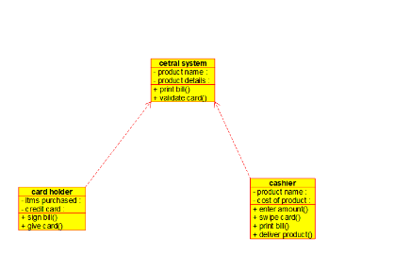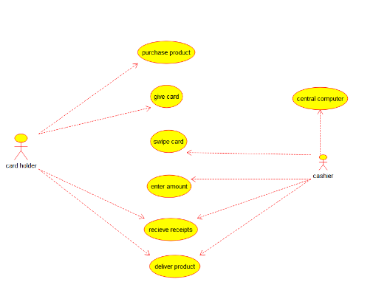

8.Develop a system using UML for Software Personnel Management System. It should be used to process the details of a person who works in a software company. The details are to be stored in the central management system for cross-checking the person’s details. 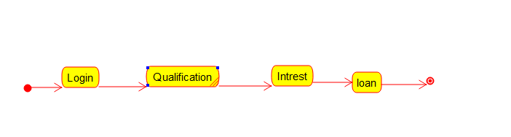

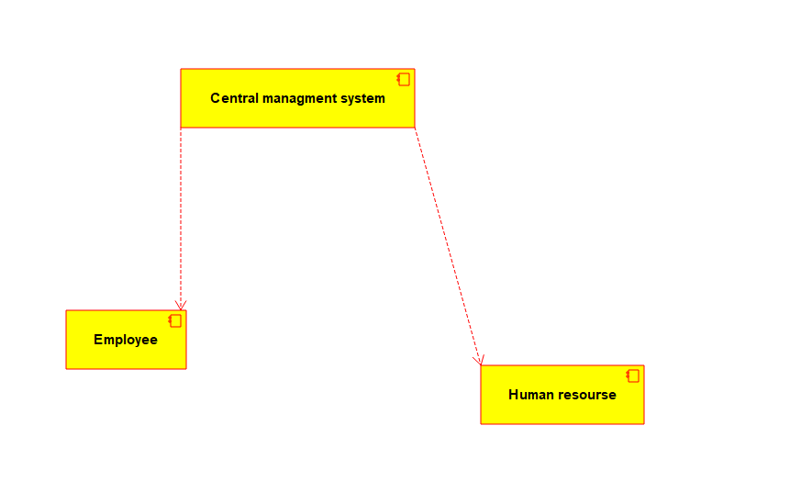

9. Develop a system using UML for E-Book Management System. It should be designed to manage the books that were read through the internet. That should consist of the details of the e-book that were read by the user online. It will be controlled by the central system. This system should act as a backup of all details together.

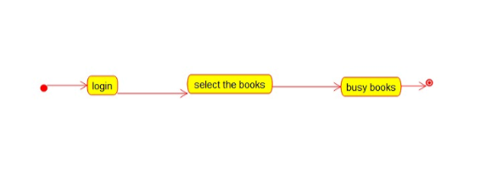

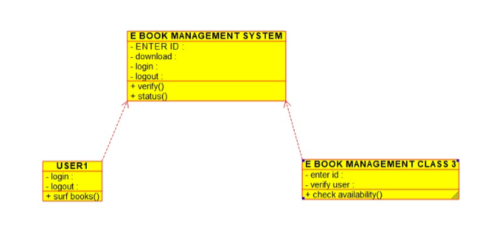

10.Develop a system using UML for Recruitment System, to recruit the applicant for a particular job in the company. It was controlled by the central management system to manage the details of the particular applicant who has to be recruited by a company.

